Seizure: What It Is, Causes, Symptoms, Treatment & Types-H1
Author : Dr. Rakesh Ranjan, Sr. Consultant & Director, Neuro Sciences

Priority | Search Volume | Keyword Intent | ASV
P1 | seizure | Informational | 110000
P1 | seizure symptoms | Informational | 9900
P1 | types of seizures | Informational | 9900
P1 | seizure treatment | Informational | 5400
P2 | different types of seizures | Informational | 210

Title- All about seizures: signs, types, and treatment options.
Description- Sudden brain activity surges cause seizures, leading to symptoms like jerking or unresponsiveness. Types and treatments depend on the cause.
Slug- /what-is-a-seizure
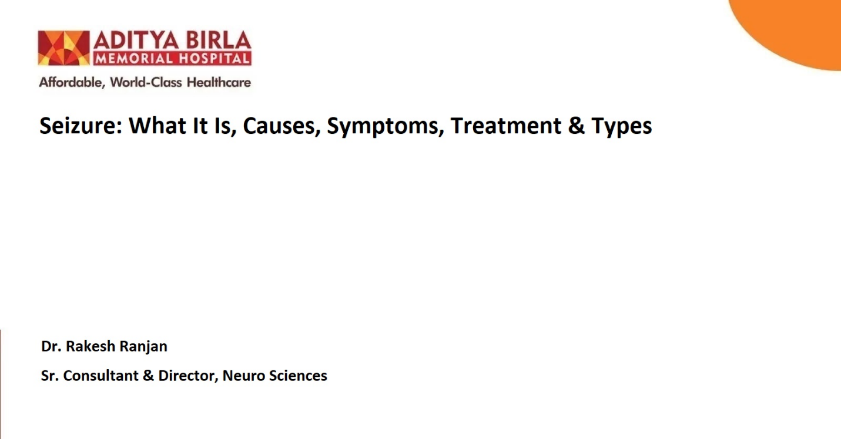

Seizures are sudden, uncontrolled electrical disturbances in the brain that can affect behaviour, movements, sensations, or even consciousness. They vary widely in severity and duration, ranging from brief episodes of confusion to full-body convulsions. While experiencing a single seizure may not necessarily indicate a chronic condition, recurrent seizures are often associated with epilepsy.
This comprehensive guide will walk you through seizure symptoms, causes, types of seizures, treatment options, and when to seek medical attention.

What Is a Seizure? -H2
A seizure occurs when there is abnormal electrical activity in the brain. The brain communicates through electrical signals, and any disruption to this process can lead to a seizure. While anyone can experience a seizure under certain conditions, some individuals may have an underlying condition, such as epilepsy, that makes them more prone to recurrent seizures.

Common Causes of Seizures- H2
Seizures can be triggered by various factors, including:
- Neurological conditions: Epilepsy is one of the most common causes.
- Head injuries: Trauma to the brain can disrupt electrical signals.
- Infections: Conditions like meningitis or encephalitis can increase the risk.
- Stroke: A lack of blood flow to the brain can lead to seizures.
- Brain tumours: Abnormal growth can affect brain function.
- Metabolic imbalances: Low blood sugar, dehydration, or electrolyte imbalances.
- Substance abuse: Alcohol withdrawal or drug use can act as triggers.
- Genetic factors: Inherited conditions may increase susceptibility.

Seizure Symptoms- H2
The symptoms of a seizure depend on the area of the brain affected and the type of seizure. Some common seizure symptoms include:
- Sudden confusion or disorientation
- Loss of consciousness or awareness
- Jerking or twitching movements of the limbs
- Staring spells or unresponsive episodes
- Changes in mood or sensory perception
- Uncontrollable muscle movements or rigidity

The severity and combination of symptoms vary based on the different types of seizures.

Types of Seizures-H2
Understanding the types of seizures is essential for accurate diagnosis and treatment. Seizures are generally categorized into two main types: focal seizures and generalized seizures.

1. Focal Seizures-H3
Focal seizures originate in one specific area of the brain. They are further classified into:
- Focal aware seizures: The person remains conscious and aware but may experience unusual sensations, such as tingling or visual disturbances.
- Focal impaired awareness seizures: The person may appear confused, unaware, or engage in repetitive movements.

2. Generalized Seizures-H3
Generalized seizures affect the entire brain. These include:
- Absence seizures: Often characterized by a brief lapse in awareness, often mistaken for daydreaming.
- Tonic-clonic seizures: Involve muscle stiffening, jerking movements, and loss of consciousness.
- Myoclonic seizures: Sudden, brief jerking or twitching movements.
- Atonic seizures: A sudden loss of muscle tone, causing the person to collapse.
- Tonic seizures: Sudden muscle stiffening.
- Clonic seizures: Repeated jerking movements.
Each type presents unique challenges, making diagnosis critical for effective management.

Seizure Diagnosis: How Are Seizures Identified?-H2
Diagnosing seizures involves a detailed evaluation to determine the underlying cause, type, and severity. Accurate diagnosis is essential for effective treatment, as it guides the medical team in tailoring an appropriate management plan. The process typically includes the following steps:

1. Medical History and Symptom Analysis-H3
The first step in diagnosing seizures involves gathering a detailed medical history. This includes:
- Personal medical history: Any prior episodes of seizures, head injuries, infections, or other conditions.
- Family history: A history of epilepsy or neurological conditions in close relatives.
- Symptom description: Patients (or witnesses) are asked to describe the event in detail, including symptoms before, during, and after the episode.
Common questions include:
  - What happened before the seizure (e.g., aura or warning signs)?
  - How long did the episode last?
  - What movements, behaviours, or symptoms were observed?

2. Physical and Neurological Exam-H3
A physical and neurological exam helps identify potential causes of the seizure.
- Neurological tests: Assess motor function, reflexes, coordination, and balance.
- Signs of injury or infection: Doctors may look for signs of head trauma, fever, or other conditions contributing to seizures.

3. Electroencephalogram (EEG)-H3
An EEG is a critical tool for seizure diagnosis.
- What it does: Measures electrical activity in the brain and identifies abnormal patterns associated with seizures.
- How it works: Electrodes are placed on the scalp to record brainwave activity.
- Types of EEG tests:
  - Routine EEG: Conducted for a short period.
  - Ambulatory EEG: Monitors brain activity over 24 hours or longer.
  - Video EEG: Combines EEG monitoring with video recordings to observe and correlate physical symptoms with electrical activity.

4. Imaging Tests-H3
Imaging studies help detect structural abnormalities or injuries in the brain.
- Magnetic Resonance Imaging (MRI): Provides detailed images of the brain to identify tumours, structural abnormalities, or scarring.
- Computed Tomography (CT) Scan: Useful in emergency settings to detect bleeding, fractures, or other acute conditions.
- Positron Emission Tomography (PET) or Single-Photon Emission CT (SPECT): Evaluates brain metabolism and blood flow to pinpoint seizure activity.

5. Blood Tests-H3
Blood tests identify metabolic imbalances, infections, or genetic conditions that may trigger seizures. Commonly tested parameters include:
- Electrolyte levels (e.g., sodium, potassium).
- Blood sugar levels.
- Markers for infections or autoimmune disorders.
- Toxin or drug levels if substance exposure is suspected.

6. Neuropsychological Testing-H3
This evaluates cognitive function, memory, and emotional well-being, especially for individuals with recurrent seizures or epilepsy. It helps assess how seizures impact daily life and guides rehabilitation planning.

7. Provocation Tests-H3
In certain cases, doctors may attempt to provoke seizure activity in a controlled environment to observe the episode and correlate it with brain activity.
- Sleep deprivation EEG: Lack of sleep may trigger a seizure, providing diagnostic information.
- Hyperventilation or photic stimulation: Involves exposure to triggers such as flashing lights.

Seizure Treatment-H2
Treatment for seizures focuses on managing the underlying cause, reducing the frequency and severity of episodes, and improving quality of life. Here are common approaches to seizure treatment:

1. Medications-H3
Medications control abnormal brain activity and are often the first line of treatment. The type of AED prescribed depends on the seizure type and individual needs.

2. Lifestyle Changes-H3
- Adequate sleep and stress management are essential.
- Avoiding known triggers, such as flashing lights or excessive alcohol consumption, can help reduce episodes.

3. Dietary Therapies-H3
A high-fat, low-carbohydrate diet has been shown to reduce seizures in some individuals, particularly children with epilepsy.

4. Surgical Options-H3
In cases where medications fail, surgery may be recommended. Surgical procedures include:
- Removing the area of the brain causing seizures.
- Implanting devices like vagus nerve stimulators to regulate brain activity.

5. Alternative Therapies-H3
Techniques such as yoga, meditation, and biofeedback may complement traditional treatments by reducing stress and improving overall well-being.

Also read: Understanding Dengue Fever: A Complete Guide

When to See a Doctor-H2
It’s important to seek medical attention if you or someone you know experiences:
- A seizure lasting more than five minutes.
- Recurrent seizures within a short period.
- Difficulty breathing or regaining consciousness after a seizure.
- Seizures occurring for the first time.

Living with Seizures-H2
Living with seizures requires careful management and support. Here are a few tips:
- Always take prescribed medications as directed.
- Communicate with your healthcare provider about any changes in symptoms.
- Educate family and friends about seizure first aid.
- Wear a medical alert bracelet for emergencies.

Final Thoughts-H2
Seizures can be life-altering, but with proper treatment and support, many people lead fulfilling lives. Understanding the different types of seizures, their symptoms, and available treatments is key to managing the condition effectively. If you suspect seizures or are at risk, consult a specialist to create a personalized care plan.

FAQs-H2
Are seizures very serious?-H3
The seriousness of a seizure depends on its type and cause. While some seizures, like those caused by temporary issues such as fever or low blood sugar, may resolve without long-term effects, others can be life-threatening. For instance:
- Prolonged seizures (lasting more than 5 minutes) or recurrent seizures without recovery (status epilepticus) require immediate medical attention.
- Repeated seizures due to epilepsy can disrupt daily life, affect cognitive function, and increase the risk of accidents or injuries.

Can seizures be cured?-H3
Currently, there is no permanent cure for epilepsy, a condition characterized by recurrent seizures. However, effective treatments can significantly reduce or even eliminate seizures in many cases. Anti-seizure drugs help control symptoms in about 70% of people with epilepsy when appropriately prescribed.

References:-H2
Huff JS, Murr NI. Seizure. [Updated 2023 Feb 7]. In: StatPearls [Internet]. Treasure Island (FL): StatPearls Publishing; 2024 Jan-. Available from: https://www.ncbi.nlm.nih.gov/books/NBK430765/
CDC. Types of seizures [Internet]. Epilepsy. 2024 [cited 2024 Nov 18]. Available from: https://www.cdc.gov/epilepsy/about/types-of-seizures.html
Nih.gov. [cited 2024 Nov 18]. Available from: https://pmc.ncbi.nlm.nih.gov/articles/PMC10140944/

